

**PROJECT REPORT**

**B. Tech (CSE(AI)) (2021 Batch)**

**Declaration**

We hereby declare that this project submitted to Centre is a record of original work done under the guidance of

Dr. Gopalkrishnan, Faculty Associate of the department of Computational Engineering Mechanics (CEM), and Dr. Nimal Madhu, Faculty Associate of the department of Introduction to Electrical Engineering (IEE), Dr. Navneeth Haridasan Faculty Associate of the department of Mathematic for intelligent systems (MIS), Amrita University Coimbatore.

Date: 19.02.2022

Place: Ettimadai

**ACKNOWLEDGMENT**   
  
The completion of this project has been made possible by the efforts of many. We would like to thank Dr. Sasangan Ramanathan, Dean- Engineering, our faculty for the course 21PHY104, Dr. Gopalkrishnan, and our faculty for the course 19AIE104, Dr. Nimal Madhu, our faculty for the course 19MAT105, Dr. Navneeth Haridasan, for their unstinting support. We would also like to extend our gratitude to our friends and family who have aided us throughout the project.

**Computational Engineering Mechanics  
&  
Introduction to Electrical Engineering  
&  
Mathematics for Intelligent Systems**

**TEAM MEMBERS**

**VIKHYAT BANSAL [CB.EN. U4AIE21076]**

**VIGNESH M. [CB.EN. U4AIE21076] MARREDDY MOHIT SASANK REDDY [CB.EN. U4AIE21076] YARRAM SRI SATHWIK REDDY [CB.EN. U4AIE21076]  
  
  
  
  
QUESTIONS**

* **PART - A**  
  **Write a computer program to solve the system of linear equations to determine the value of the member forces for the truss shown in the figure for different values of P ranging from 10 kN to 100 kN with an increment of 5 kN.**



* **PART - B**

**Create MATLAB code to mimic the operating concept of the OPAMP-based system given below.**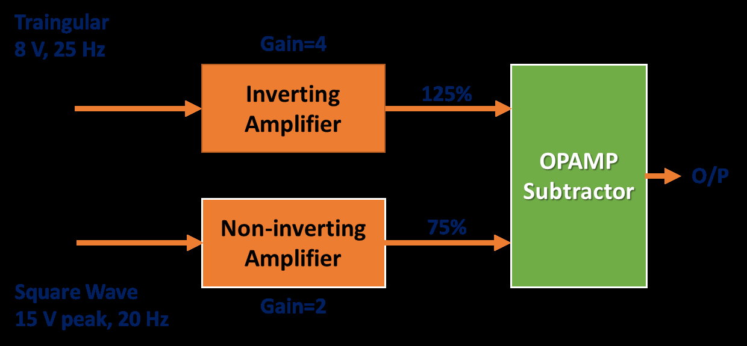

•**MATLAB codes should estimate the instantaneous voltage values at all the stages.**

•**If the final output is applied to an inductor, demonstrate the variation in the energy stored in it. Choose a suitable numerical approach.**

**ABSTRACT**

A truss is an object which is assembled using triangles together in such way that it acts as a single object which can be used on roofs, bridges and towers etc. We are going to calculate the member forces shown in image so that truss as a whole remains in equilibrium.  
OPAMP(Operational Amplifiers) is a DC coupled electronic voltage amplifier. They are currently present in numerous types each with it’s own specification and one of the most common is IC-741.

**INTRODUCTION**

**CEM**

The **Fink trusses** are commonly used truss in homes and bridge architecture.  
 It was originally founded as a bridge truss although its current use in bridges is rare.

A fink roof truss is one of the most commonly used type of truss, providing a simple, and cost efficient roofing solution.

The “fink” is a basic webbed truss design that provides the most economical roof solution.

The web members form a ‘W’ alphabet to provide a high strength structure with excellent load-carrying capacity. The roof load is transmitted entirely to support on the wall plates.

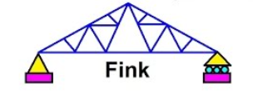

**METHODS TO SOLVE THE Q ASKED**

There were two methods considered to solve the Q.   
1.) Creating FBD of each joint and creating equal number of equations and unknown variables(in this case 16) and solving them computationally using matrices and knowledge of formulae on MATLAB to solve linear equations of form AX = B.  
2.) Using method of Sections to divide the figure symetrically and using the concept of Rigid body equilibrium on joints, considering all possible support joints and equating forces accordingly and taking moment about any point as zero to get required variables and for remaining variables creating FBD and getting equations and unknown variables.



**Error faced while using METHOD 1**

While calculating member forces using FBD at each joint and calculating those equations computationally created discrepancy that is when calculated using different formuales.  
That is each formulae is used to calculate or solve system of linear equations of form AX = B but the value coming at each instance was different for every formulae creating error.  
From the pictures below the computational error can be seen:-

**USING BACKSLASH  
  
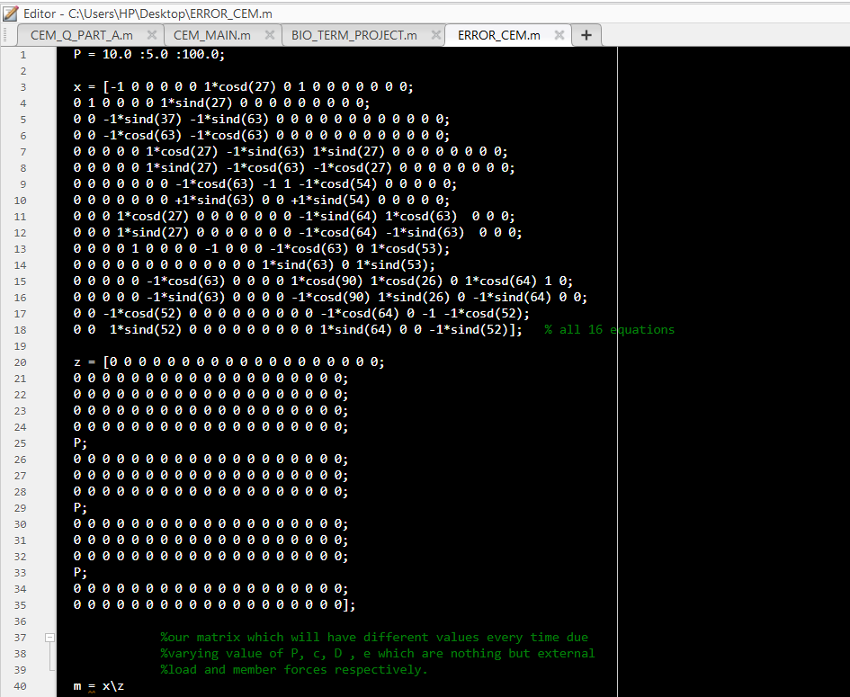**

**OUTPUT:**

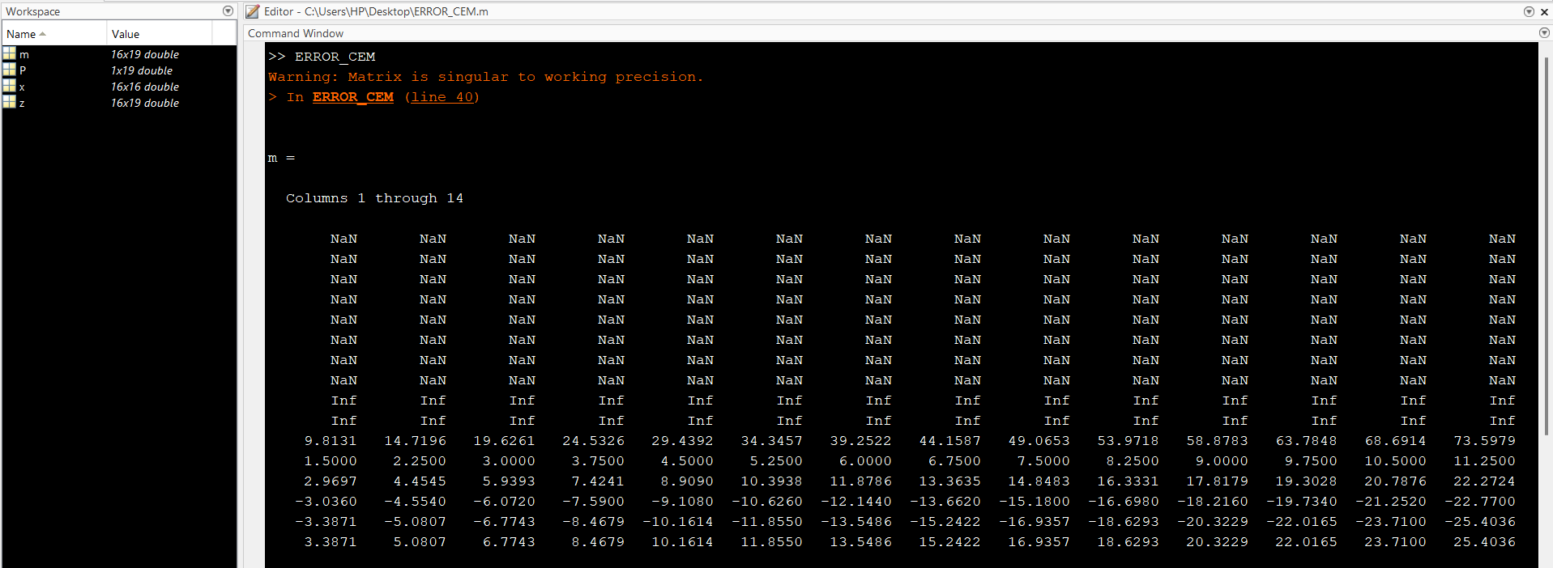

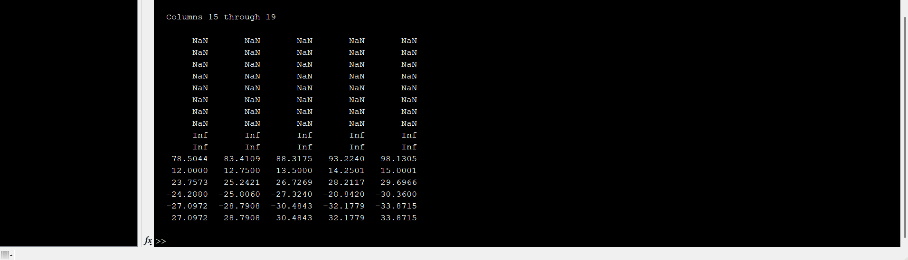

**USING PSEUDOINVERSE**

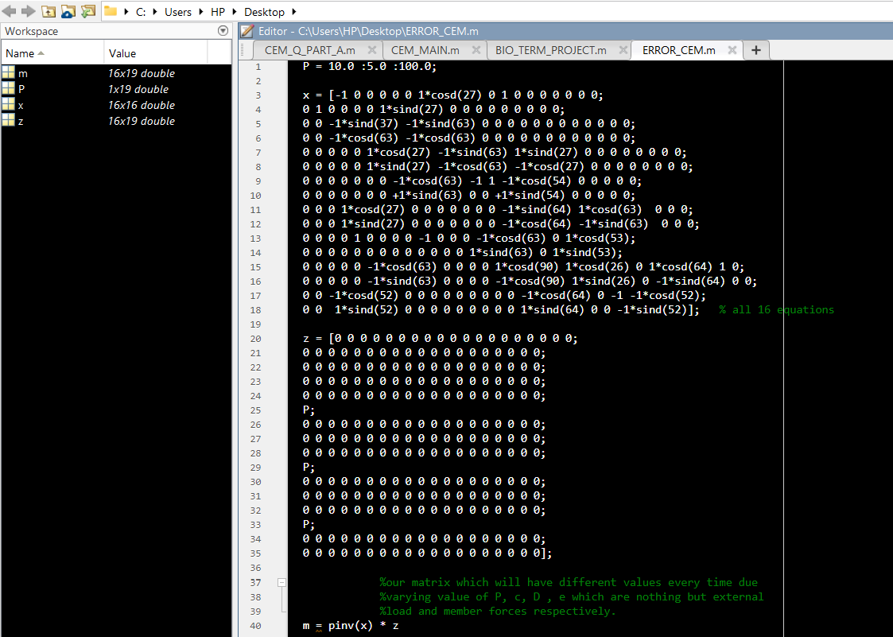

**OUTPUT**:  
  
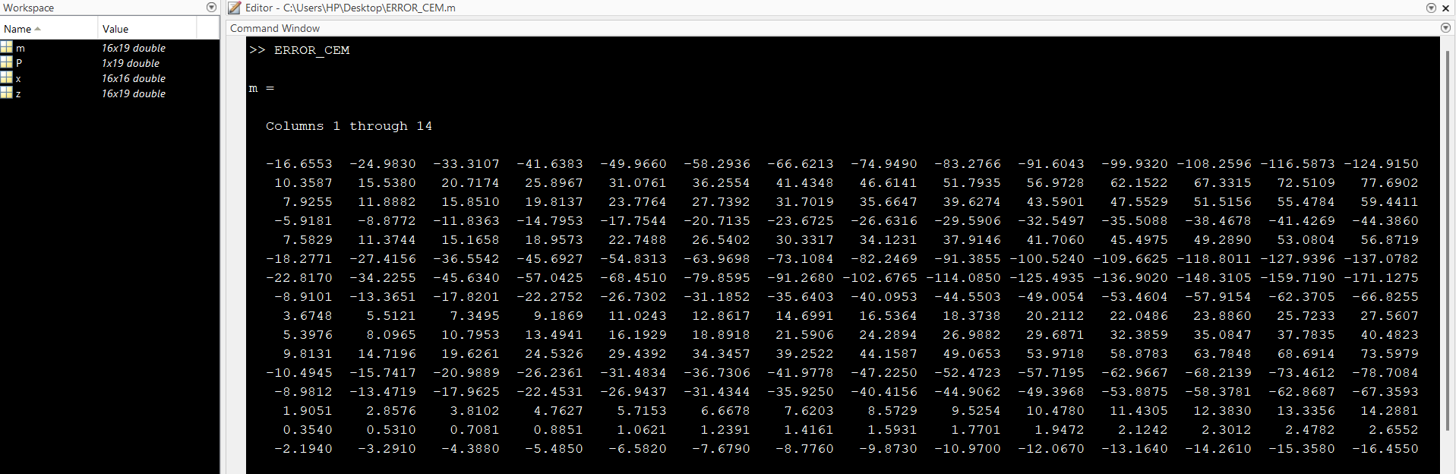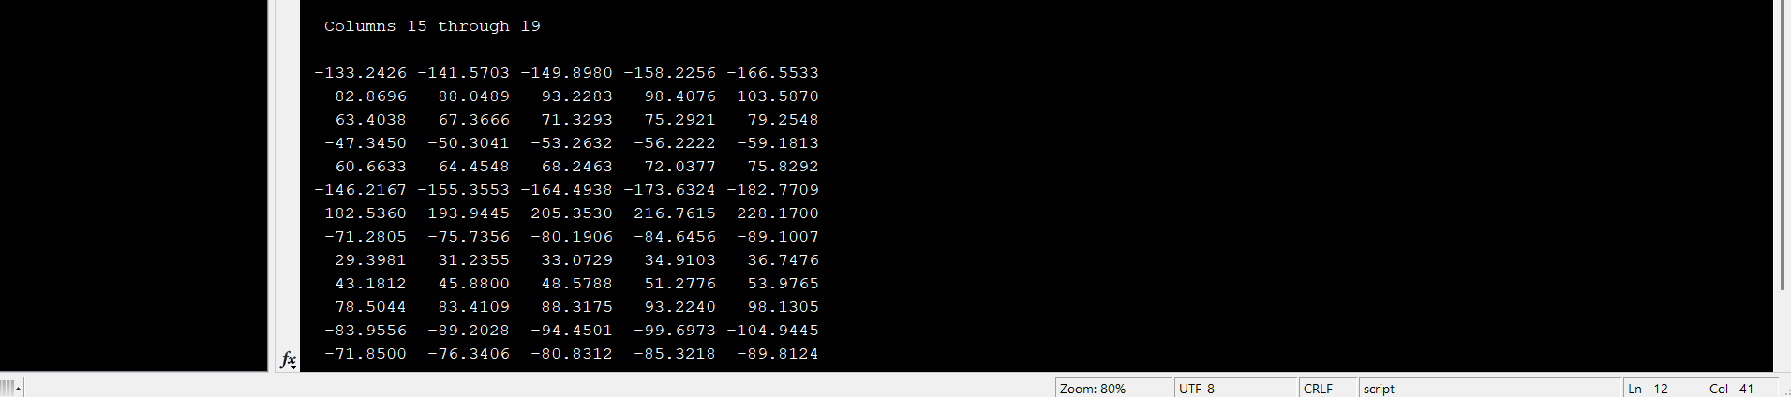

**USING RREF**

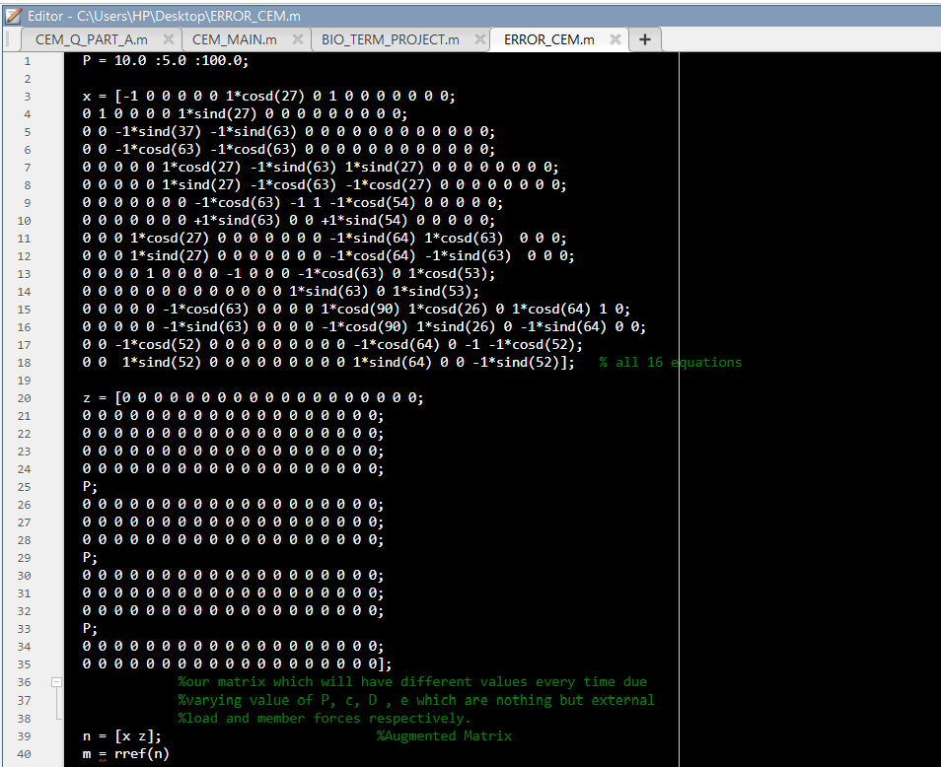

**OUTPUT:**

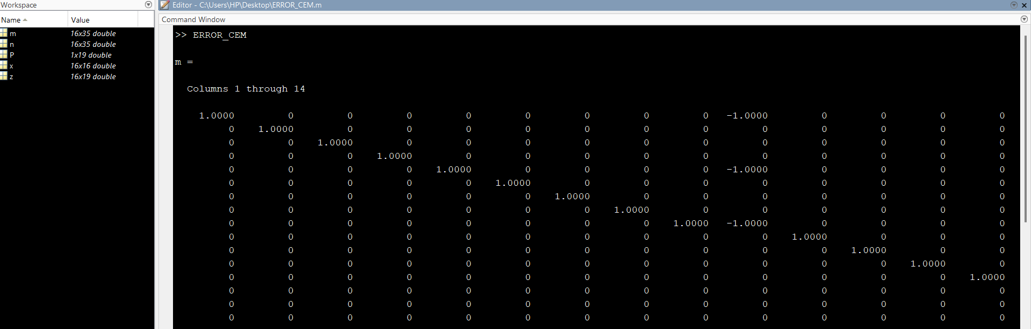

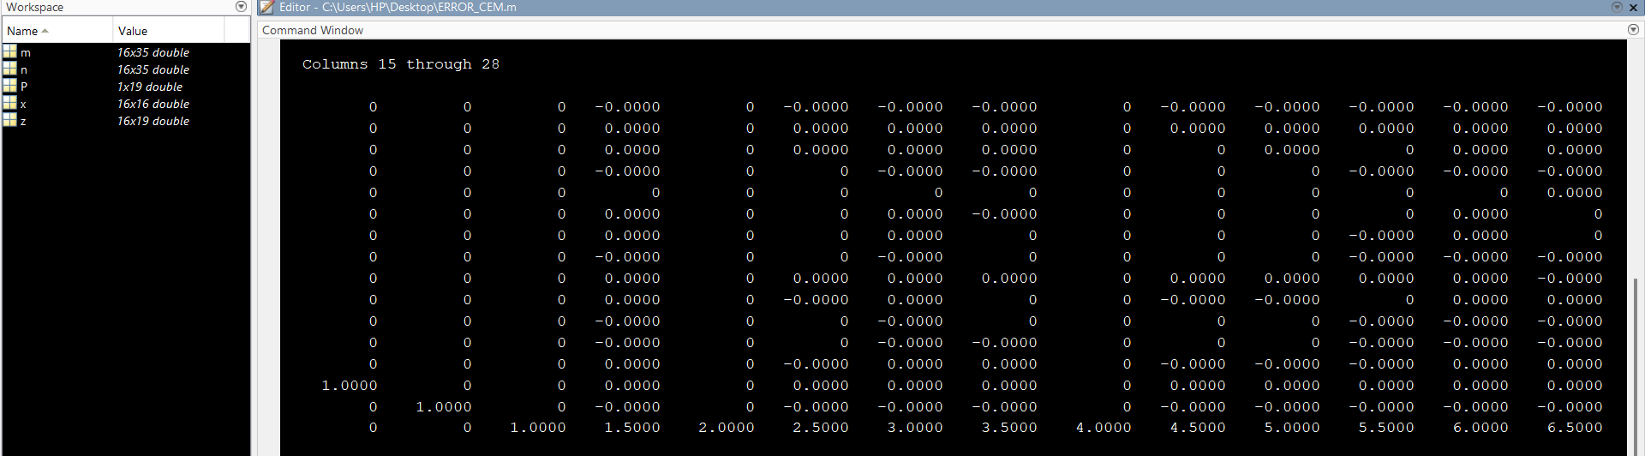

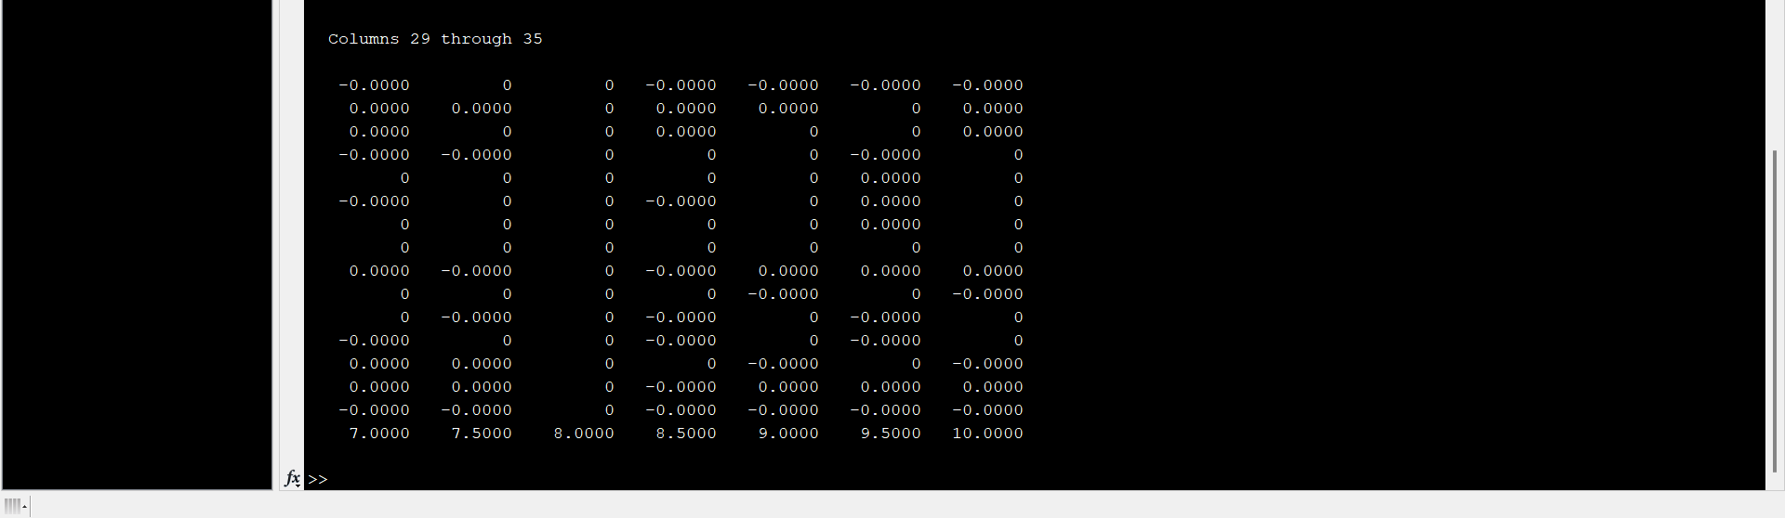

**SOLVING THE Q ASKED USING METHOD 2**

* Starting from calculation of each and every angle that each rod of makes with X-Axis and Y-Axis. Angles can be calculated using our basic knowledge geometry of 10+2 .

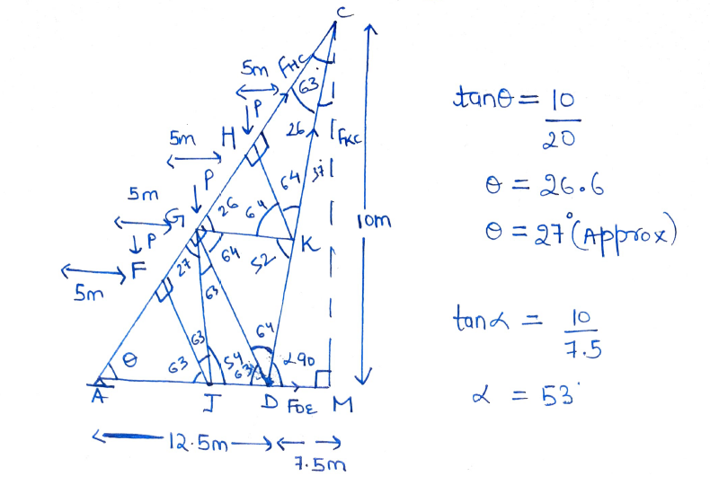

* Now using concept of rigid body equilibrium and keeping moment about the required joints as zero we calculate member forces FHC, FKC, FDE .

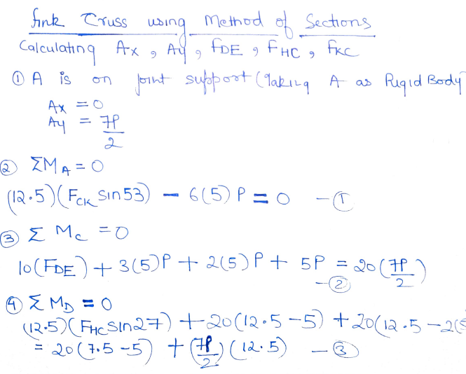

* Creating matrix for the 3 equations with 3 unknown variable with varying value of external load P from 10kN to 100kN with step size 5kN.

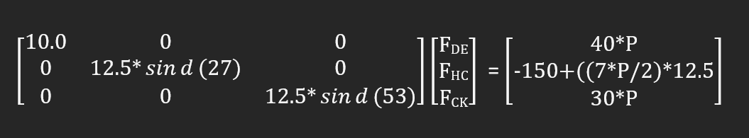

* Solving this matrix using MATLAB using formulae to solve matrix of form AX = B.

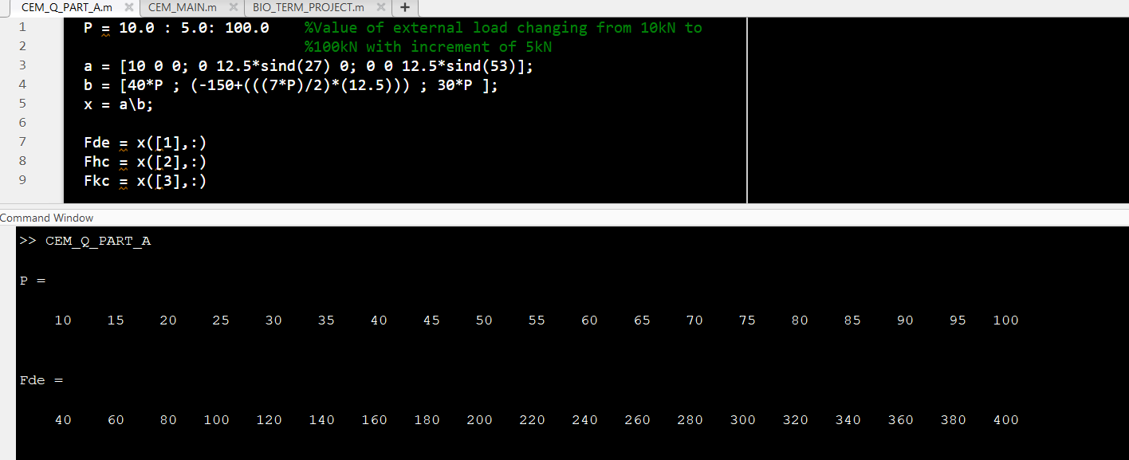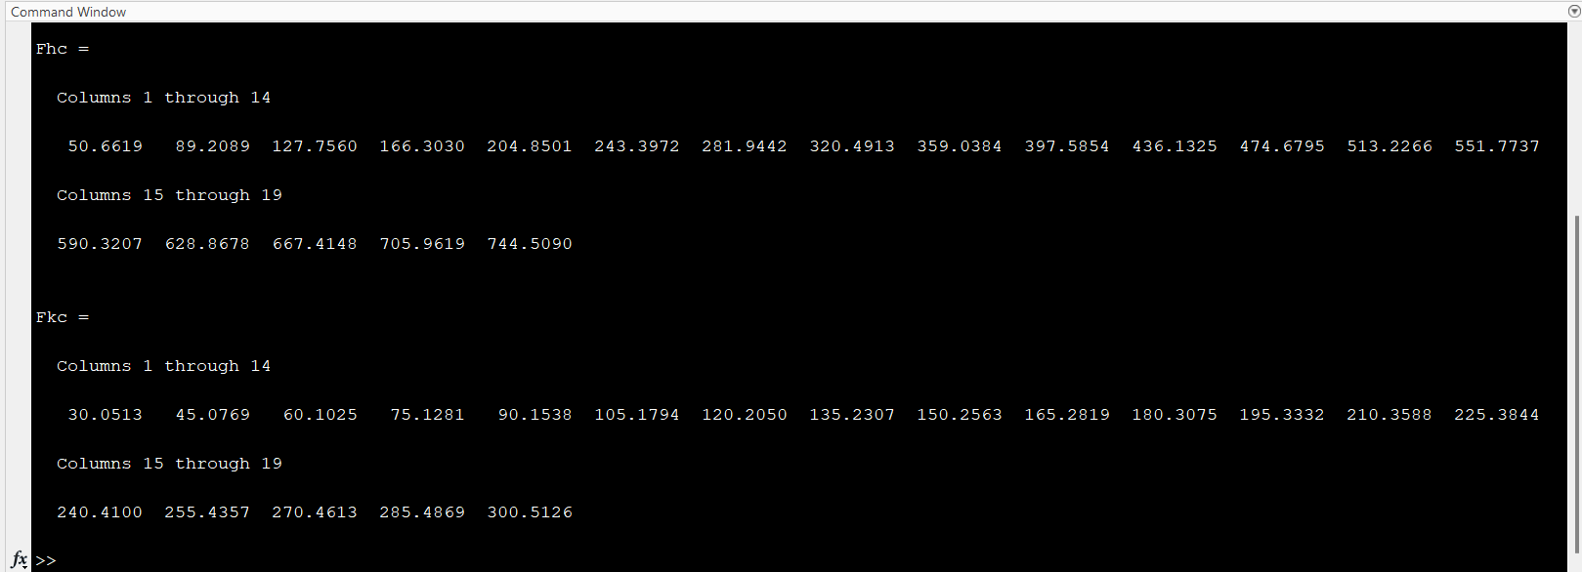

* Creating FBD for each joint to get equations with unknown variables.

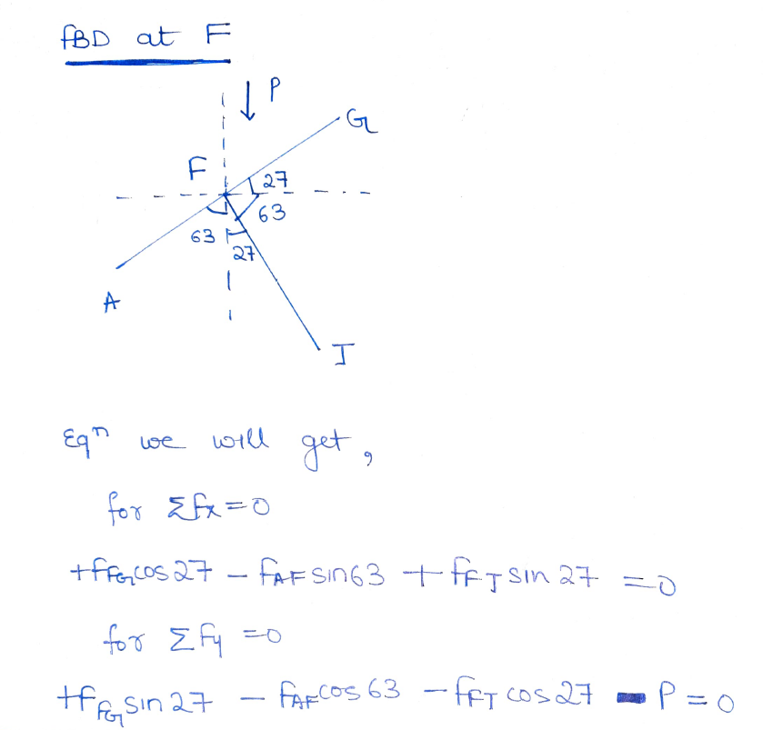

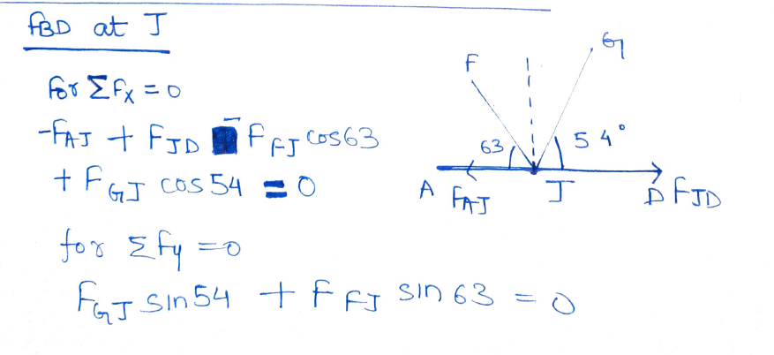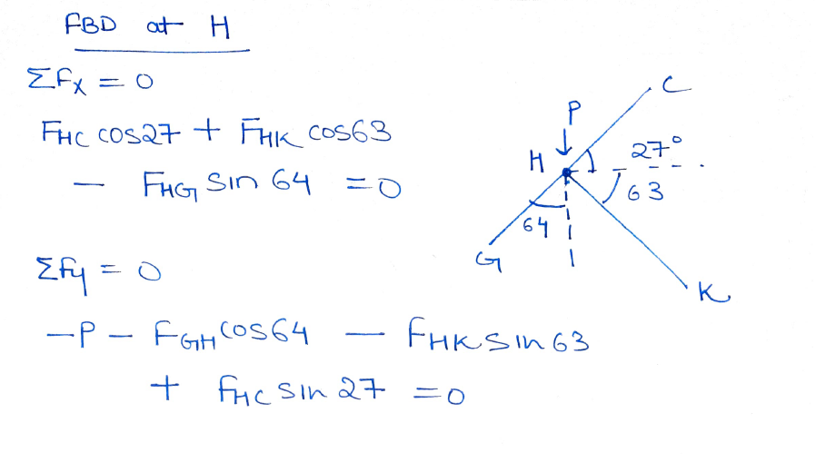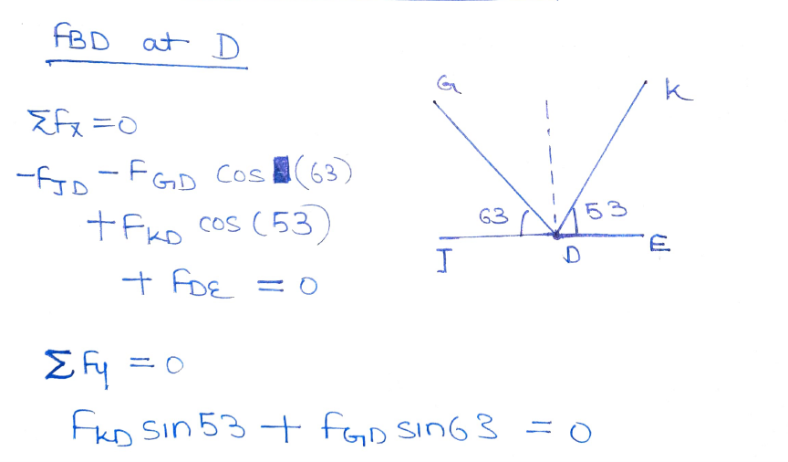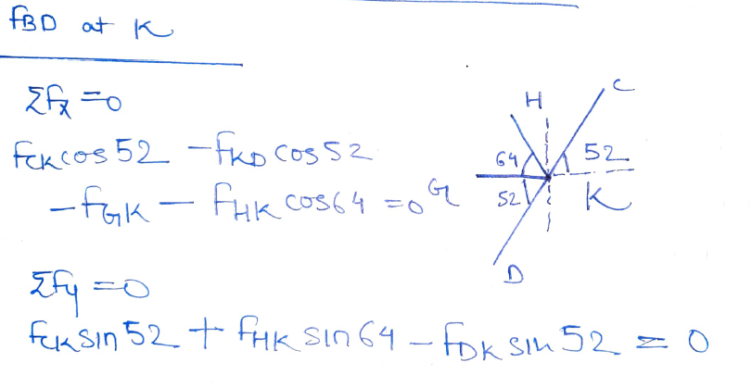

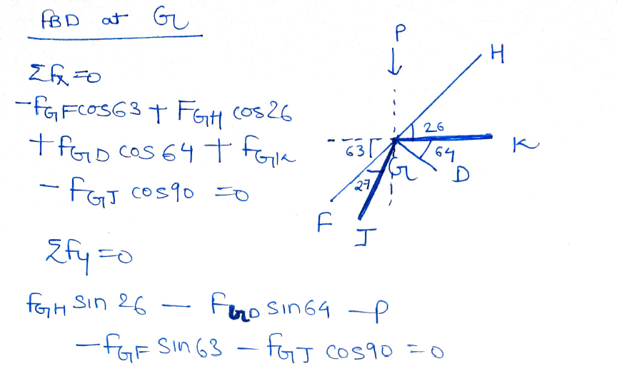

* Creating matrix with 12 Equations but 11 unknowns as one of the member force has been calculated earlier namely FDE.

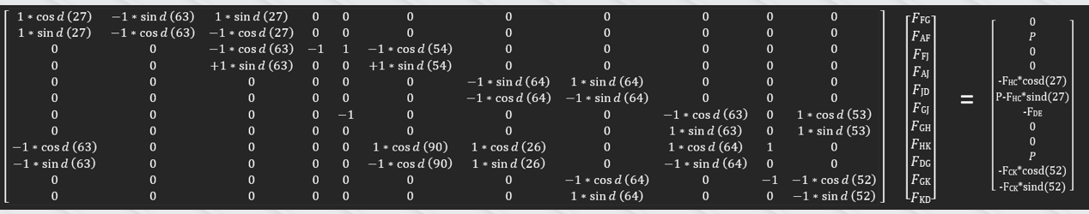

* Solving these equations using MATLAB using BACKSLASH which is used to solve linear equations AX = B and we can also use PSEUDOINVERSE to get the same.

(Remember if image seems non-understandable due to small font size.

Press CTRL + Scroll UP/Down.)

**BACKSLASH:**

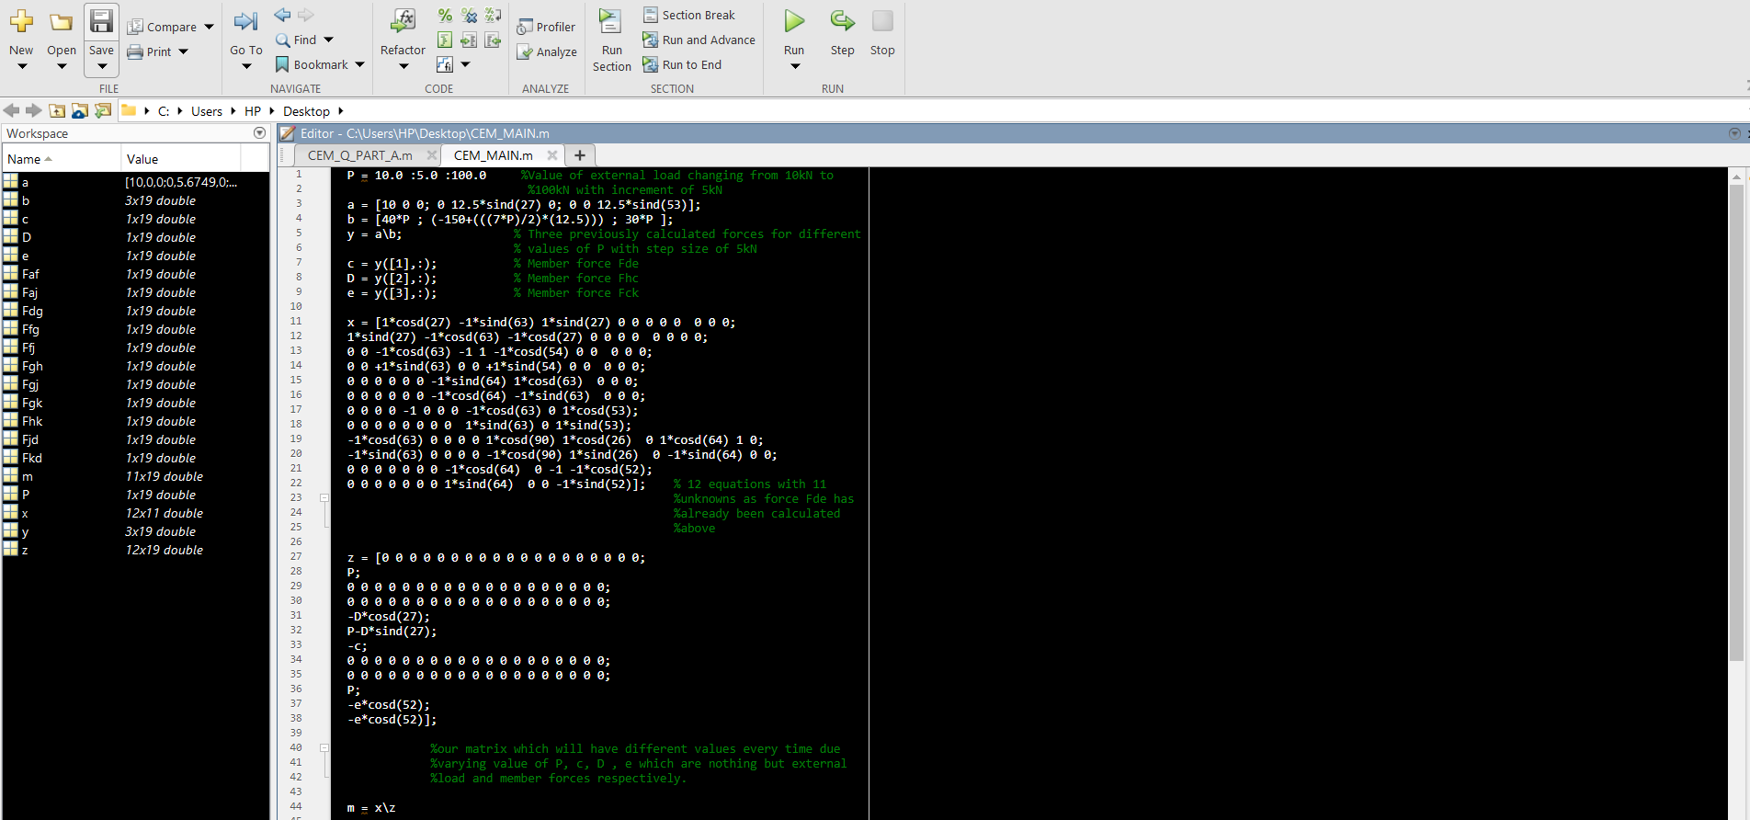

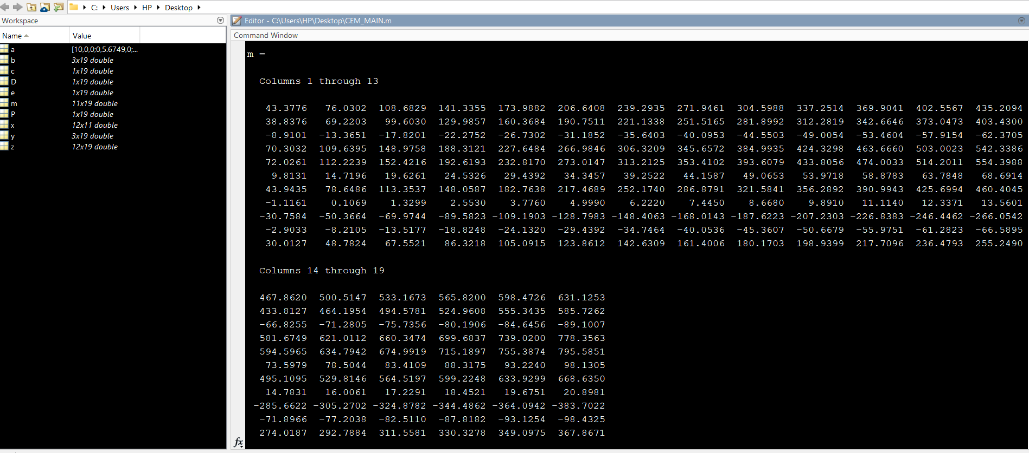

**PSEUDOINVERSE:**

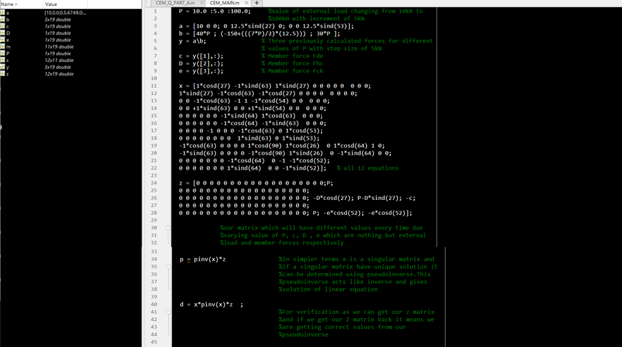

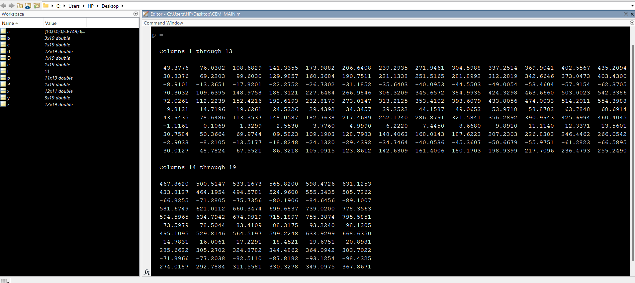

Values of Unknown for different Values of Load P are nothing but 1 row with 19 columns.  
For Example : FFG is

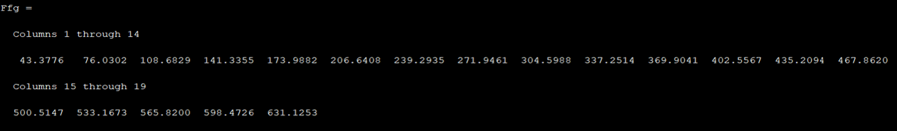

**IEE**

**OPAMP :**

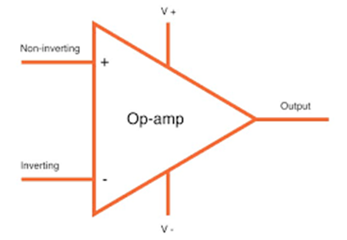

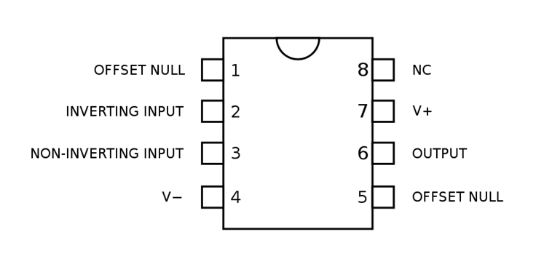

* An operational amplifier is a multistage high gain amplifier treated as single entity. Normally opams have a differential input and a single ended output. In other words, one input produces a inverted output signal, and the other input produces a non-inverted output signal.
* Its basic role is to amplify and output the voltage difference between the two inputs pins.

**INVERTING AMPLIFIER:**

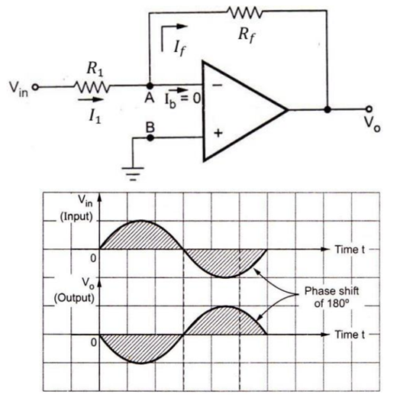

* An inverting amplifier is an operational amplifier circuit with an output voltage that changes in the opposite direction as the input voltage. By changing phase difference by 180 degrees.
* This means that if the input pulse is positive, then the output pulse will be negative and vice versa.

We can calculate the gain of op amp gain with formula

Av=-Rf/Ri.

We can calculate the output with formula

V0=-(Rf/Ri) *Vin.

If we have to calculate the summing amplifier for inverting amplifier then we have the formula as V0 = -Av*Vin

so, by using this we can solve inverting amplifier of our question

**MATLAB CODE:**

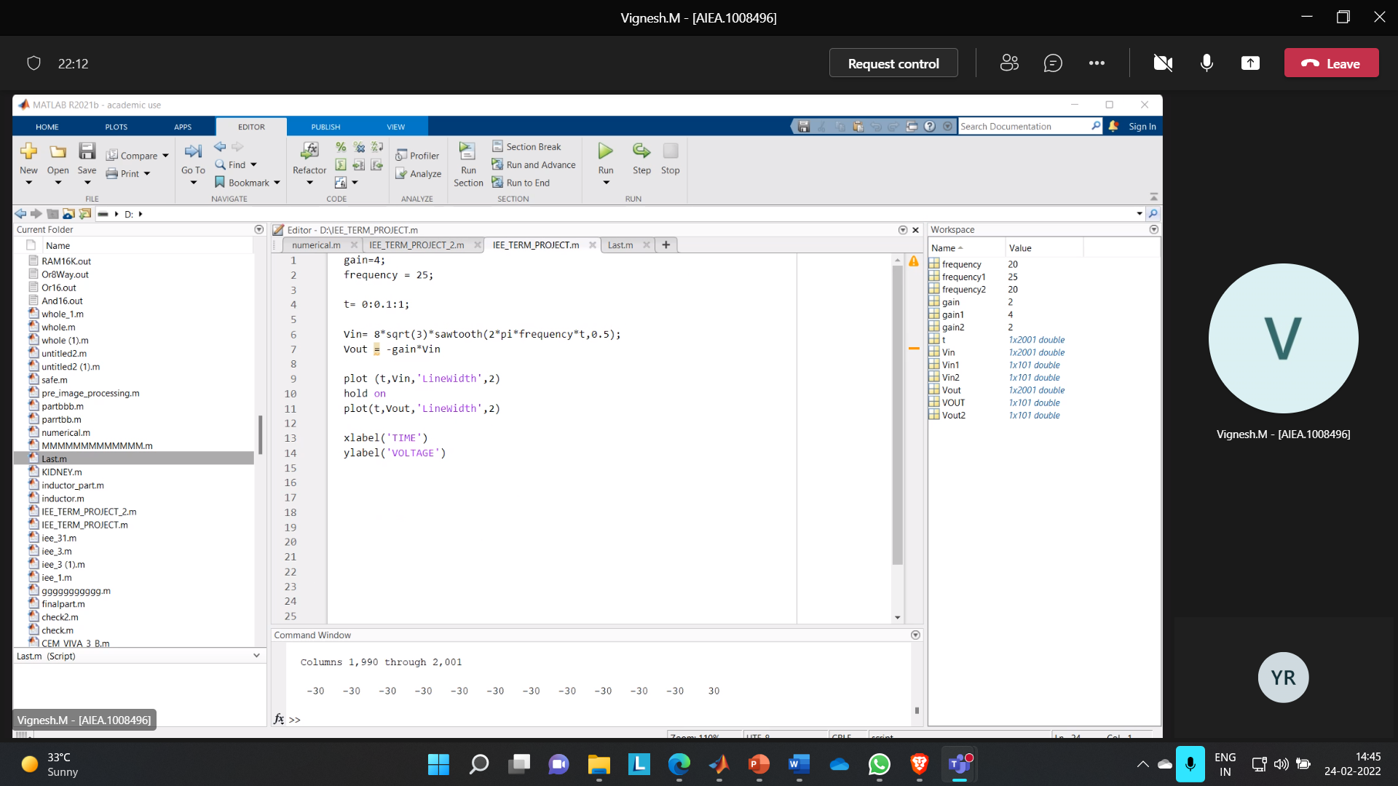

**OUTPUT:**

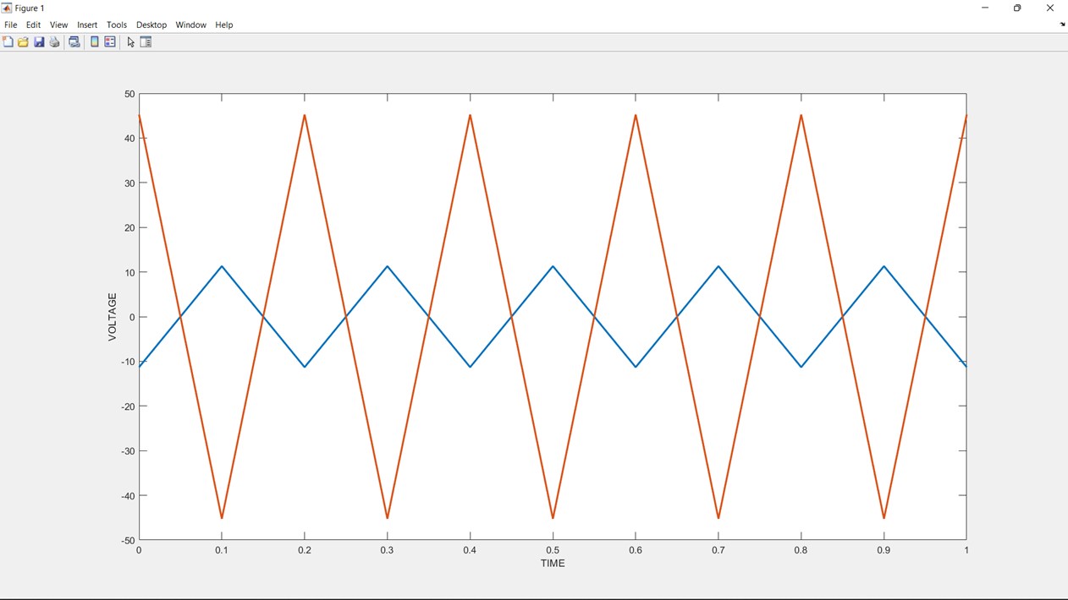

**NON-INVERTING AMPLIFIER:**

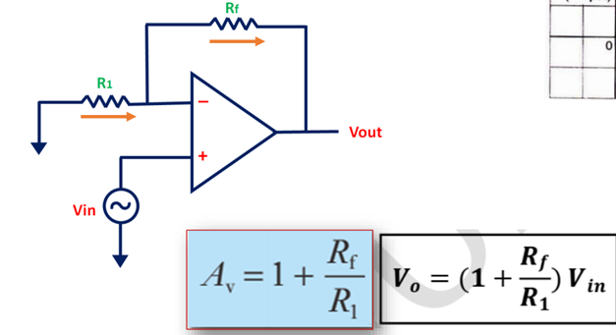

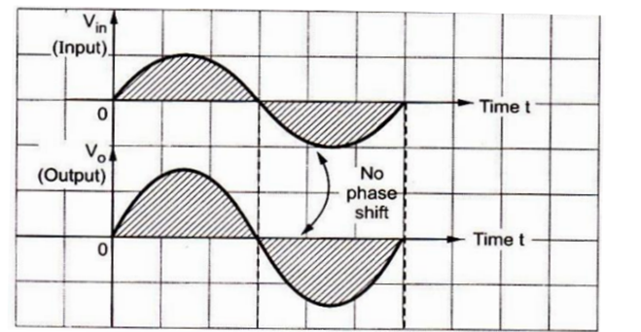

* A non-inverting opamp is an operational amplifier circuit with an output voltage that is in phase with the input voltage. Its complement is the inverting opamp, which produces an output signal that is 180 degrees out of the phase.

**MATLAB CODE:**

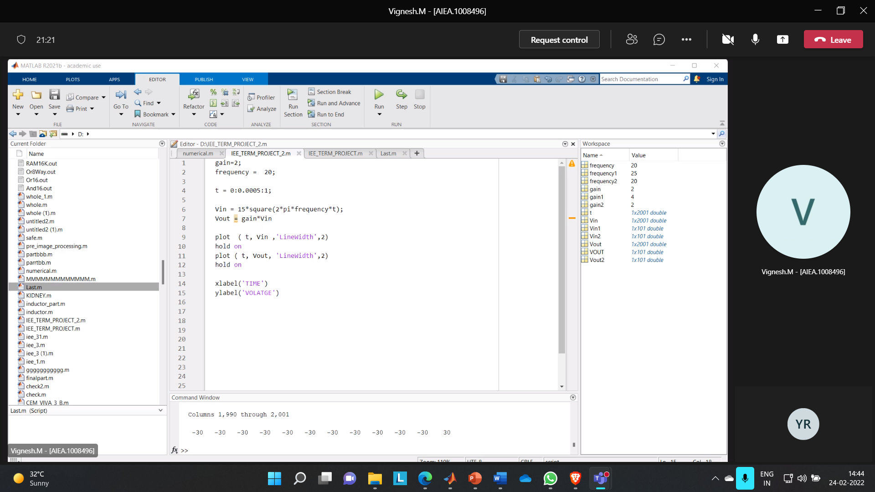

**OUTPUT:**

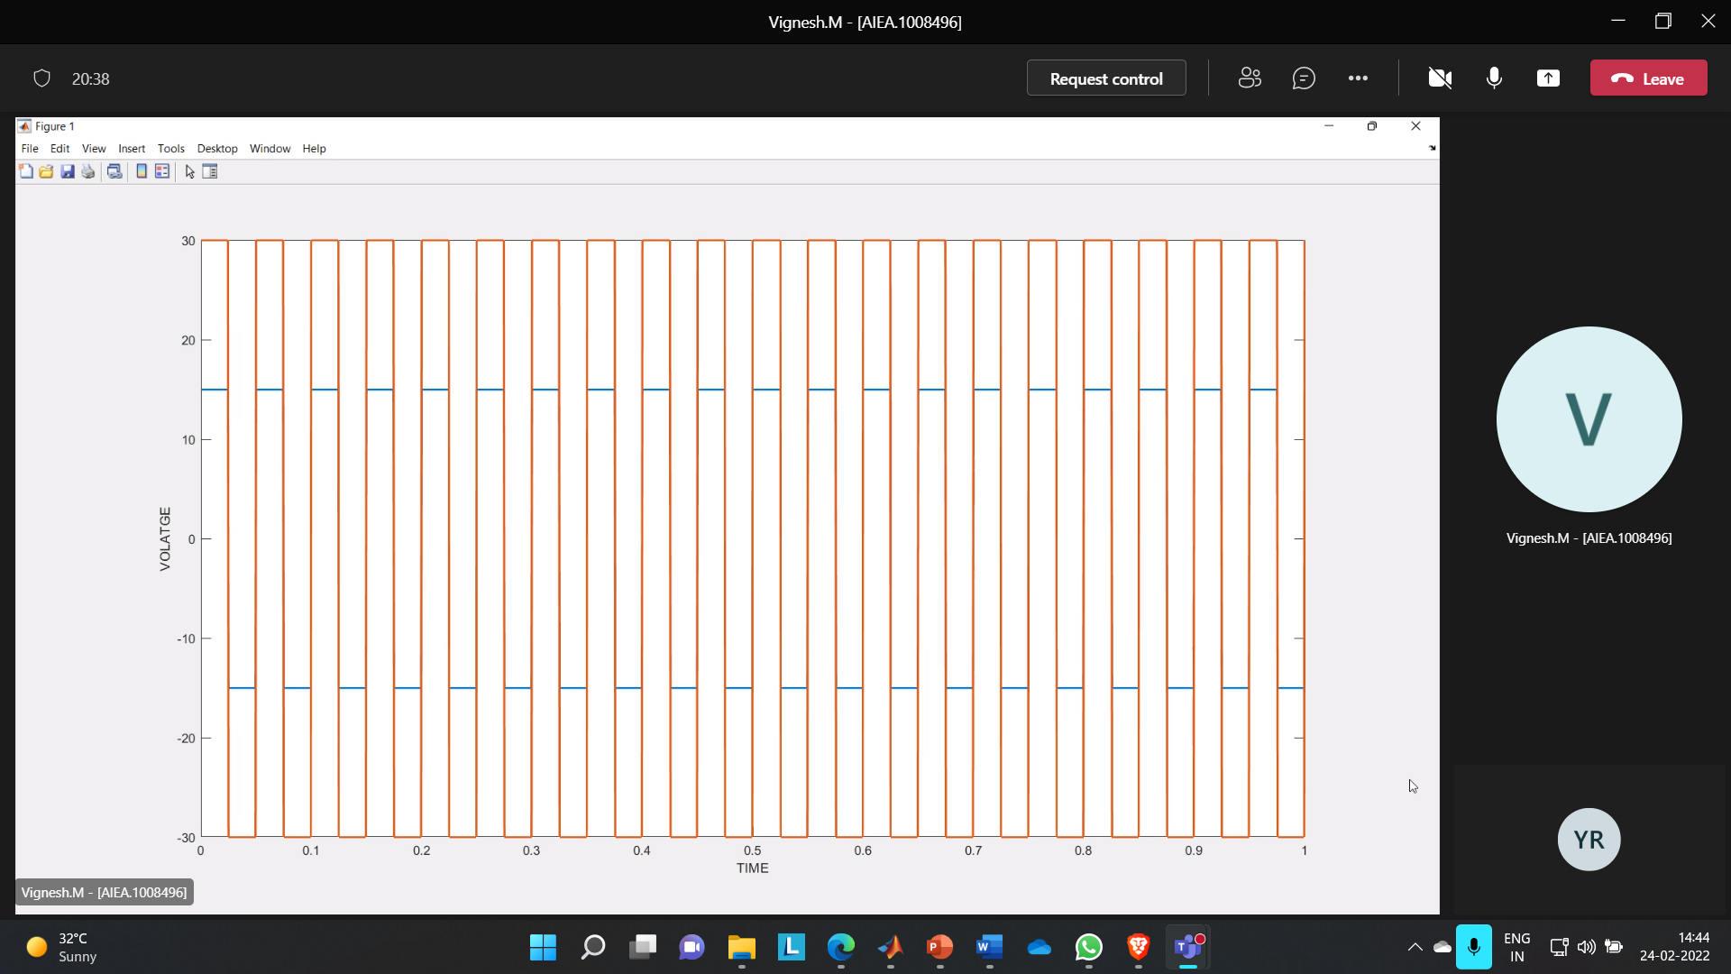

**SUBTRACTOR:**

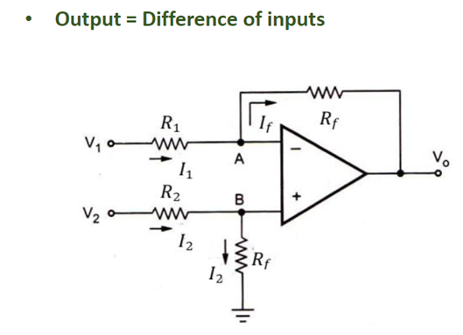

* The subtraction of the two input voltages is possible with the help of a subtractor. The subtractor using op-amp is shown in the figure. It is also called a difference amplifier.
* VA = VB = "v2" /2

R1 = R2 = RF = R

* "V1 – 0.5V2" /𝑅 = (0.5𝑉2 – 𝑉𝑂)/𝑅
* -[V1 – V2] = VO
* VO = V2 – V1

From the code the two inputs for the OPAMP subtractor is taken from the output of inverting amplifier and non-inverting amplifier.

• The first input Vin1, we are taking 125% from the output of inverting amplifier.

• The second input Vin2, we are taking 75% from the output of non-inverting amplifier.

• The output will be the subtracted part from the two inputs.

**MATLAB CODE:**

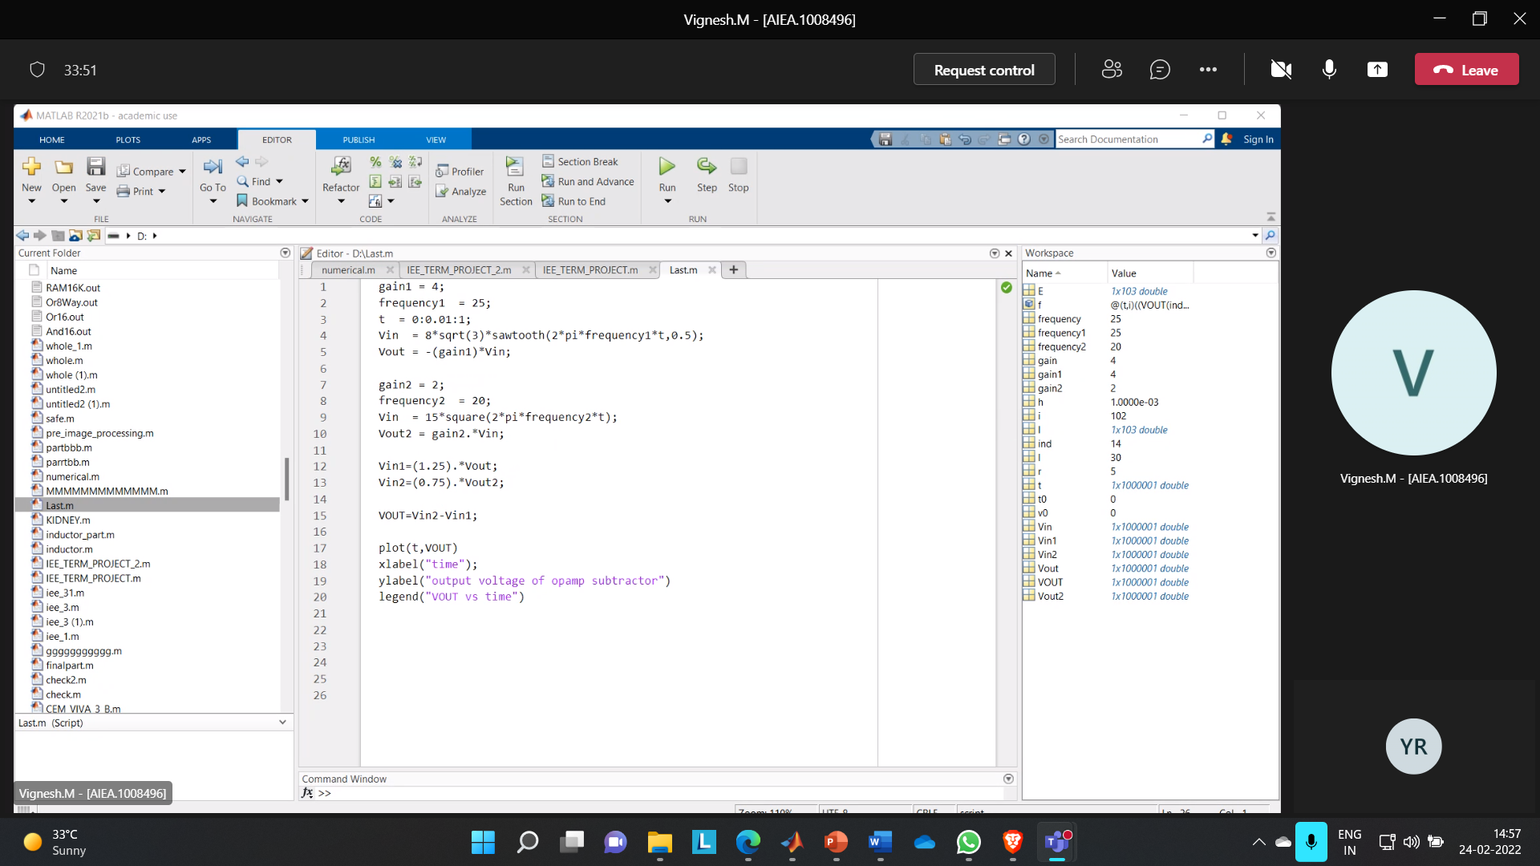

**OUTPUT:**

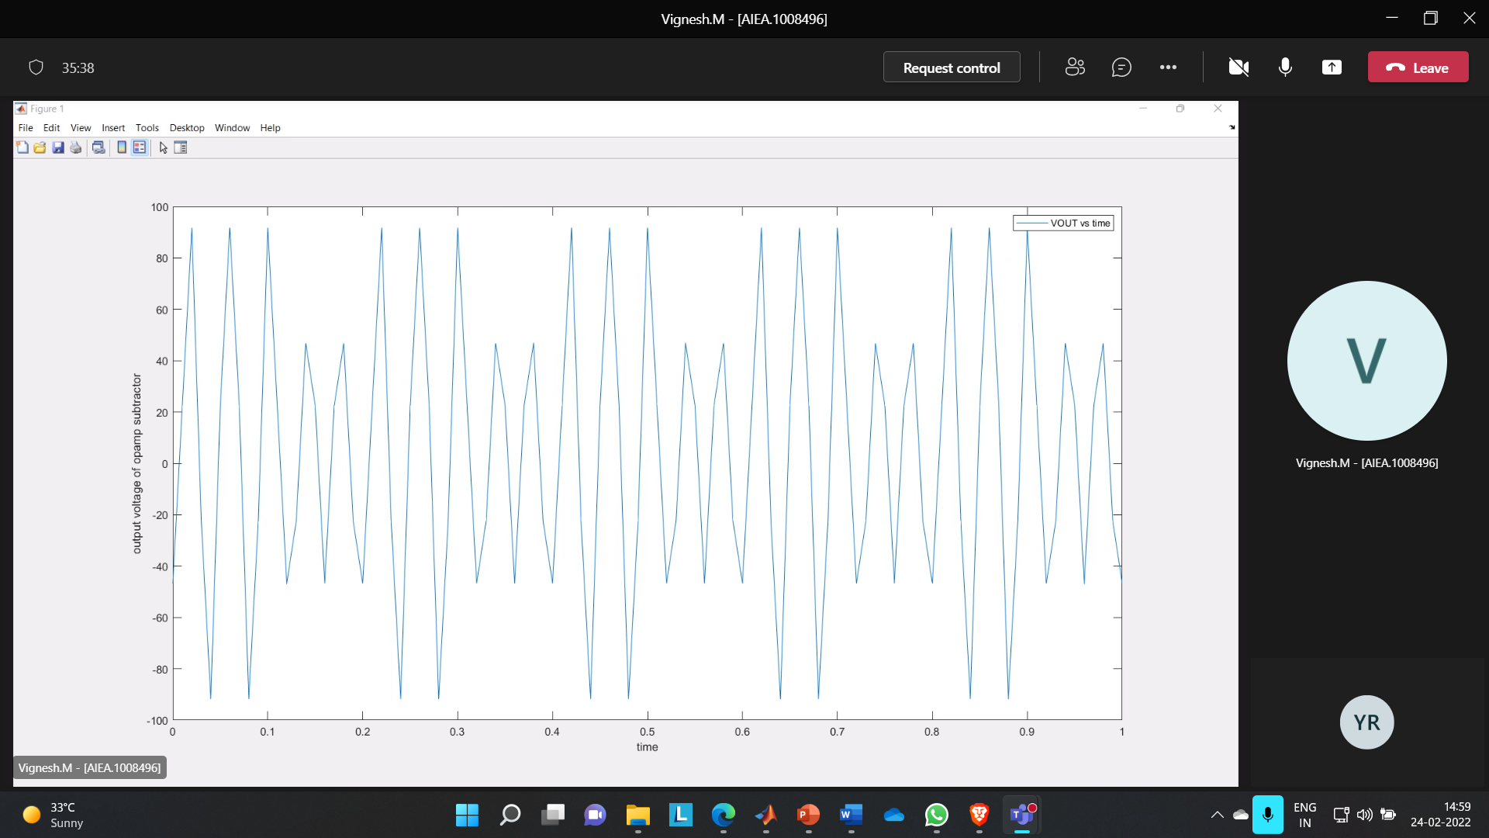

**WHAT IS NUMERICAL METHOD:**

Algorithms for computing numeric data are known as numerical methods. They are employed to deliver 'approximate' outcomes for the problems being dealt with, and their importance is recognised when solving a given problem analytically becomes impossible or exceedingly complex.

**USING EULERS METHOD:**

The Midway approach, commonly known as the second-order Runga-Kutta method, improves the Euler method by including a midpoint in each step, increasing accuracy by one order.

**MATLAB CODE:**

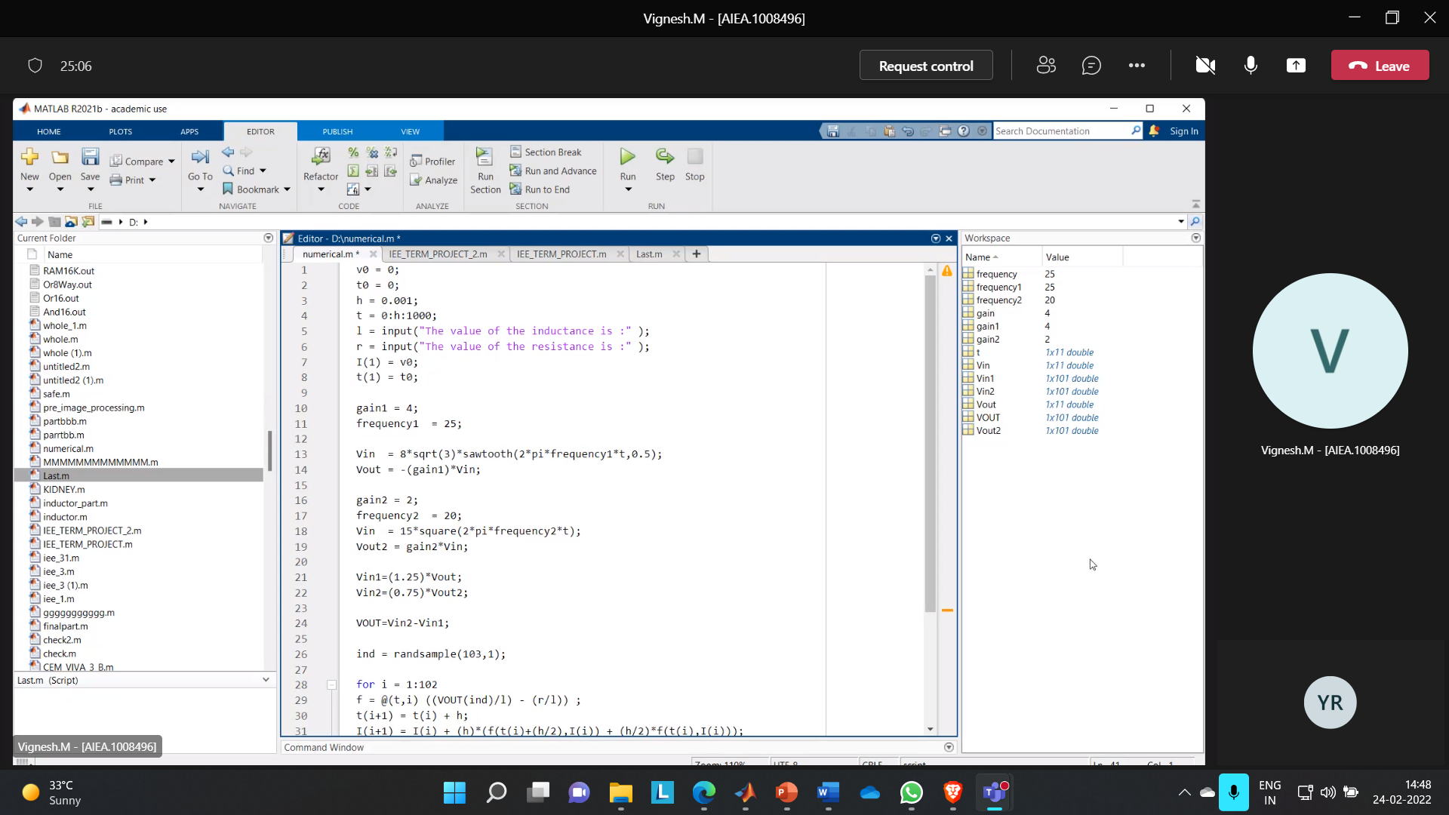

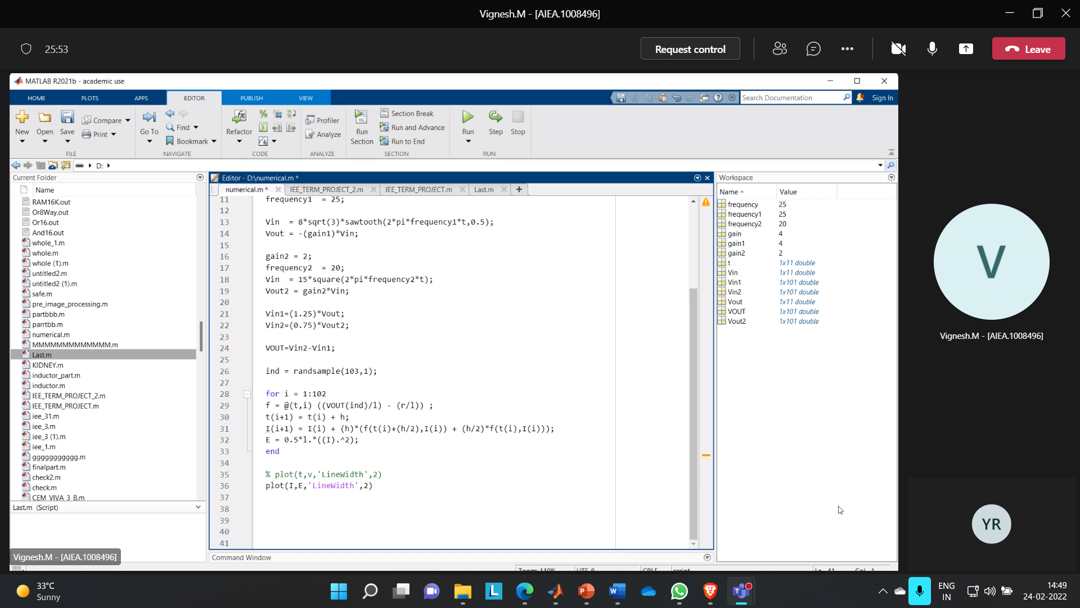

By taking inductance as 30 and resistance as 5 we are getting the following graph as output.

**OUTPUT:**

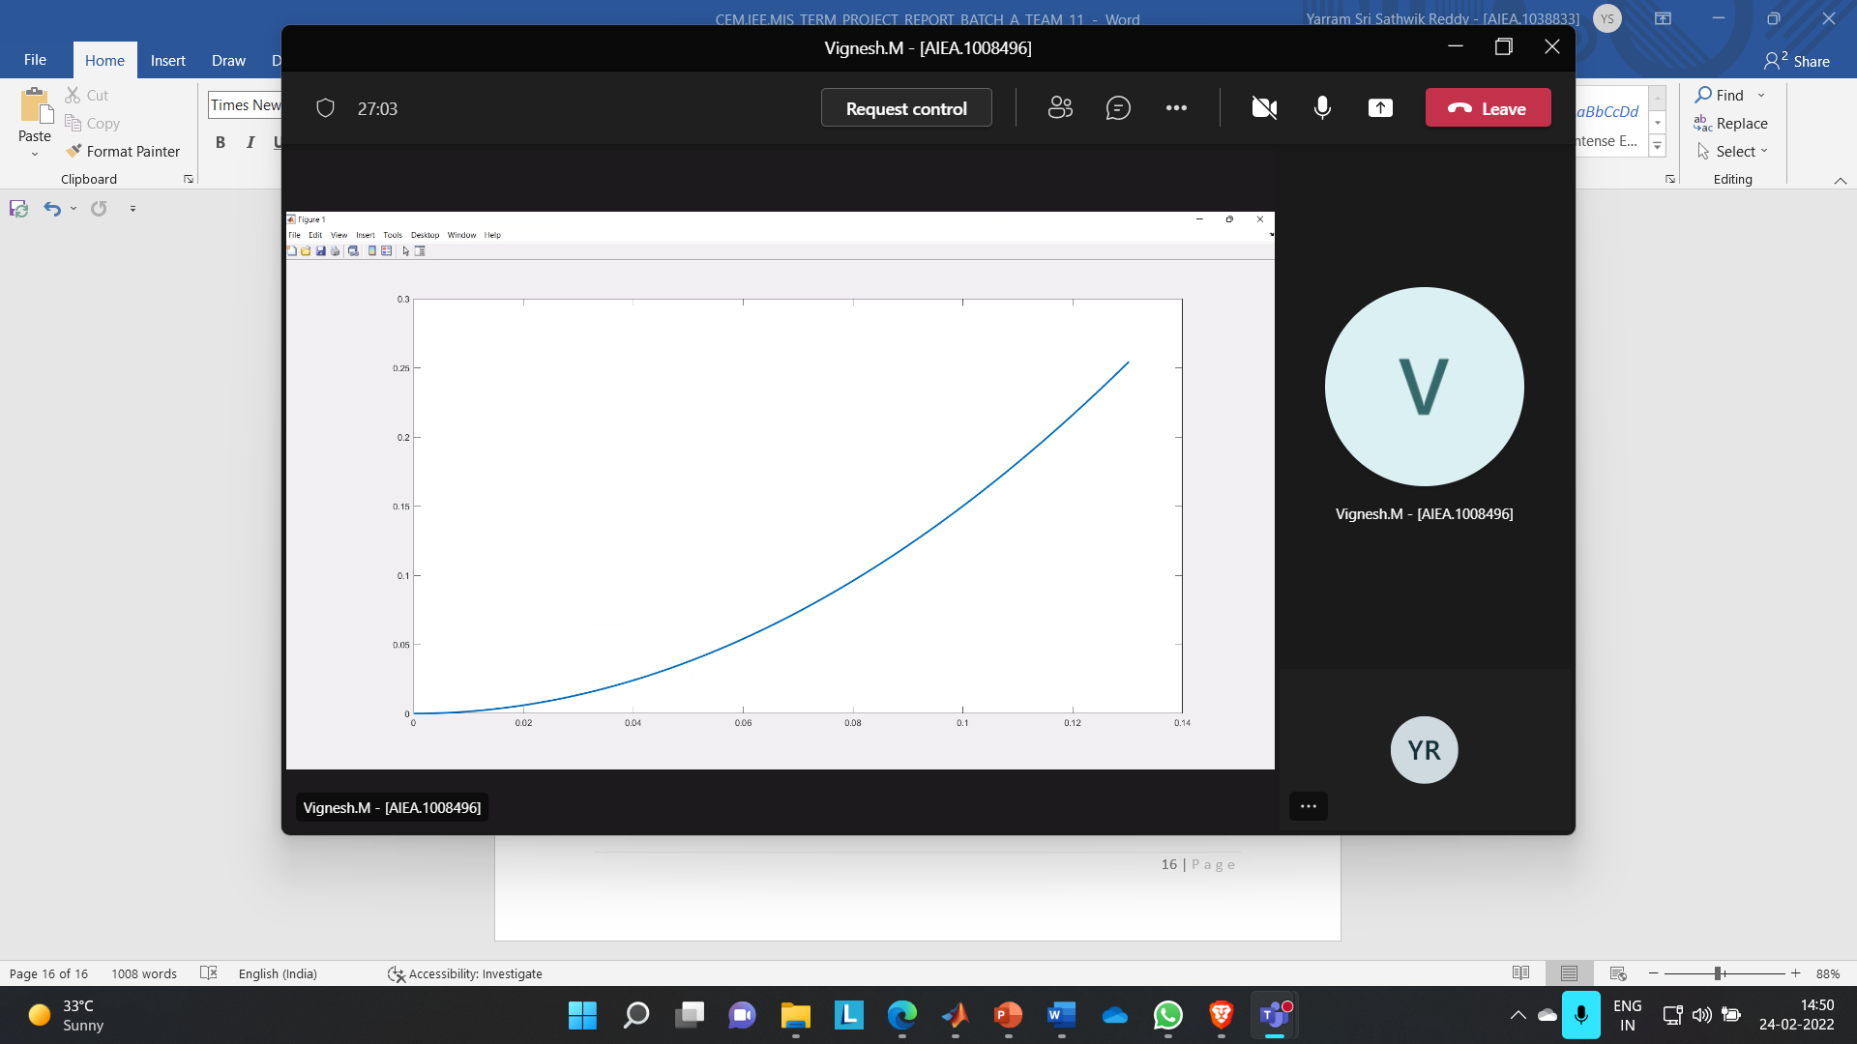

**REFERENCES**

<https://en.wikipedia.org/wiki/Fink_truss>

<https://www.electronics-tutorials.ws/opamp/opamp_5.html>

<https://www.designingbuildings.co.uk/wiki/Truss#:~:text=A%20truss%20is%20a%20structure,in%20bridges%2C%20roofs%20and%20towers.&text=Trusses%20consist%20of%20triangular%20units%20constructed%20with%20straight%20members>.

<https://www.electronics-tutorials.ws/opamp/opamp_2.html>

<https://www.maximintegrated.com/en/glossary/definitions.mvp/term/Non-Inverting%20Op%20Amp/gpk/1219#:~:text=A%20non%2Dinverting%20op%20amp,180o%20out%20of%20phase>.

THANK YOU!